**Sprint 2 Task : Evaluate Testing Frameworks**

**Introduction**

Software development requires testing to make sure that the code works as intended and stays stable during the project. For "Project Echo," I conducted a thorough analysis of testing frameworks for Node.js and Python. I examined jest and mocha for Node.js, and I concentrated on pytest and unittest inside the Python ecosystem. Based on important factors including functionality, ease of use, community support, and integration possibilities, the objective was to determine which frameworks offer the most complete, effective, and scalable testing solutions for the project.

**Python Testing Frameworks**

Although there are several testing frameworks available for Python, the most popular ones are pytest and unittest. My investigation into these two frameworks produced unique benefits and trade-offs that are necessary to choose which is most appropriate for "Project Echo."

**1. pytest**

I found pytest to be an incredibly feature-rich and adaptable testing framework. Working with it made me understand why the Python community uses it so extensively, especially for medium- to large-scale projects.

**Features**

Pytest's fixture system was the first thing that caught my eye. Fixtures offer an organised means of sharing common data or states between tests by enabling the reuse of setup code across several test methods. This, in my experience, greatly increased the manageability and scalability of complex test setups, such as initialising a database, configuring environment variables, or creating dummy data. Fixtures can be scoped to specific tests, test classes, or entire test modules thanks to the flexibility of the fixture system, which reduces the amount of redundant code.

Parameterized testing is an additional feature that I deemed helpful. This feature minimises the requirement for repeated code and guarantees thorough testing coverage for a broad range of inputs by enabling you to run a test several times using distinct sets of input data. For instance, parameterization made it easier for me to test every scenario in a neat and effective manner if I had a function that handled different input types.

Another strong feature of Pytest is the ecosystem of plugins. The functionality of pytest can be expanded with hundreds of plugins, such as those for handling more complicated test situations like parallel execution, integrating with web frameworks like Flask or Django, and producing coverage reports (pytest-cov). By eliminating the need to reinvent the wheel and automating tedious operations, this ecosystem greatly improved my testing efficiency.

**Ease of Use**

Pytest turned out to be intuitive in terms of usage. I discovered that the syntax is clear and uncomplicated, which enables me to create basic test methods without the requirement for subclassing or unique annotations. My test functions only needed to be prefixed with test_ for Pytest to recognise and execute them, saving me time from manual configuration.

Another element that caught my attention was the automatic test finding. Pytest searches the project directory and finds all test files and functions automatically, saving you the trouble of manually registering or organising tests. This guaranteed that no tests were missed, especially in large projects, and made organising my test suite easier.

The extensive reporting features of the framework were particularly noteworthy. Pytest gives a very explicit and descriptive error message when a test fails, indicating the exact values that failed as well as the location of the fault. I spent a lot less time debugging after having this kind of insight because I could understand what went wrong right away.

**Community Support**

My research revealed that the Python community supports Pytest extensively. The framework has a thriving contributor ecosystem and is constantly maintained, with frequent updates. I discovered a tonne of third-party resources, such as blog entries, tutorials, and Stack Overflow conversations, which really facilitated troubleshooting and the learning of new capabilities. The vast plugin ecosystem is evidence of the community's engagement and the adaptability of the framework.

The overwhelming number of open-source projects that use pytest, a sign of its widespread usage throughout the Python ecosystem, was another facet of community support that I found impressive. Because of its extensive usage, pytest is guaranteed to get updates and enhancements, which makes it a dependable option for lengthy projects like "Project Echo."

**Integration Capabilities**

The integration features of Pytest worked flawlessly. It interacted with Travis CI, GitHub Actions, and other continuous integration (CI) processes with ease. This was crucial for "Project Echo," which calls for maintaining excellent code quality in a variety of contexts. I could set up pytest to automatically launch tests in response to each pull request or code push, making sure that any regressions were detected as soon as possible.

The ease with which pytest interfaces with code coverage tools was also noted. I was able to produce thorough coverage reports with the pytest-cov plugin, which gave me information about the areas of the codebase that had been tested and where adjustments were required. This made sure that every crucial aspect of the programme was covered by my test suite, which was thorough.

**Conclusion on pytest**

I investigated pytest in detail and discovered that it's a great testing framework for "Project Echo." Its extensive feature set, simple syntax, and robust CI tool integration make it the best option for effective and scalable testing. Its enormous plugin ecosystem and vibrant community support further bolster its appropriateness for long-term projects.

**2. Unittest**

Unittest is a well-known tool that is the default testing framework in the Python standard library. I looked at it to see how it differs from Pytest.

**Features**

The foundation of Unittest is the xUnit family of testing frameworks, which is likely well-known to developers from other programming languages such as Java (JUnit). It offers a structure based on classes, allowing tests to be defined as methods inside of unittest.TestCase subclass. In contrast to pytest's function-based methodology, this structure felt more inflexible, although it does enforce a consistent style that can be helpful for teams who are already familiar with unit frameworks.

The unittest.mock module's mocking capabilities are one of the main aspects of unittest. This enables developers to substitute dummy objects for sections of the system being tested, simulating the behaviour of external systems such as databases or APIs. Although strong, I discovered that unittest's mocking setup necessitates more boilerplate code and configuration than pytest, since the latter allows for the addition of mock capabilities through plugins.

In addition, Unittest has two methods for setup and teardown (setUp and tearDown), which execute before to and following each test function, respectively. These techniques make sure that the test environment is set up and cleaned up appropriately, but I felt that this method was more laborious than the fixture system in Pytest. Fixtures are more adaptable, providing more precise control over the test state and permitting reuse across several tests.

**Ease of Use**

When it comes to usability, unittest is verbose compared to pytest. the necessity of a unittest subclass. It felt superfluous to write test methods and Testcase, especially for smaller applications or basic unit tests. Although developers accustomed to other xUnit frameworks may recognise this structure, it may be excessive for simple test cases.

Unittest is likewise devoid of Pytest's automated test discovery feature. Although unittest facilitates test discovery, setting up and managing bigger test suites is less straightforward due to the need for more explicit configuration. On the other hand, pytest saves a tonne of time by automatically finding all tests without the need for additional configuration.

**Community Support**

Unittest is a commonly used library framework with extensive documentation and a plethora of resources for both learning and debugging. But I discovered that unittest has less community-driven plugins and extensions than pytest. This reduces its versatility and necessitates the use of extra tools and setup for more complex use cases, such as code coverage or parallel testing.

Having said that, unittest is a reliable option for applications where minimising external dependencies is important because its presence in the Python standard library ensures long-term maintenance.

**Integration Capabilities**

As part of a CI pipeline, Unittest may be set up to execute tests, and it works nicely with CI systems. Nevertheless, it is devoid of the integrated features that Pytest provides, such as code coverage, parallel execution, and comprehensive test reporting. The test setup would become more complicated if you had to manually incorporate third-party tools like coverage.py or nose to add these functionalities.

**Conclusion on unittest**

Although unittest is a dependable and robust framework, it is not as feature-rich, flexible, or user-friendly as pytest. Unittest is a good option for smaller projects or those with fewer external dependencies. However, pytest's extensive feature set, simplicity of integration, and community support make it the superior choice for "Project Echo," where scalability and efficiency are crucial.

**Node.js Testing Frameworks**

The two main testing frameworks for Node.js that I investigated were mocha and jest. While each framework is widely used in the JavaScript community, their purposes are marginally different.

**1. jest**

During my investigation, I discovered that jest is a thorough, unconventional testing framework. Jest is a Facebook-developed tool that is very useful for testing React applications, although it also functions well with backend Node.js services.

**Features**

There's no need for additional libraries with Jest's array of built-in features, which include spies, assertions, and mocking. As a result, jest becomes a very practical and effective framework by lowering setup overhead. I didn't have to bother about setting up external libraries before I could begin creating tests.

Snapshot testing is one of the standout characteristics of jest. With the help of this capability, you can make sure that nothing unexpected has changed by capturing the output of a component or function and comparing it to subsequent test runs. This was especially helpful, in my opinion, for testing React components, as minute UI adjustments may easily go overlooked in the absence of adequate testing.

Additionally, Jest allows for parallel test execution, which divides tests among several CPU cores to dramatically speed up test runs. This offers a significant advantage over frameworks that run tests serially in that it can significantly reduce the time required for large projects to execute the whole test suite.

The integrated coverage reporting in jest is another useful feature. Code coverage is automatically measured with Jest; no other tools needed to be installed. The comprehensive and lucid coverage reports enable me to promptly locate untested portions of the programme.

**Ease of Use**

Jest was simple to set up and operate. I didn't have to bother about configuration files or manual setup in many scenarios because it comes with zero-configuration defaults. With just one command, I was able to launch Jest, which makes it perfect for projects where developers want to concentrate on creating tests rather than setting up the environment.

It was simple to read and write tests using Jest because of its clear, uncomplicated syntax, which is like ordinary JavaScript. Another aspect that caught my attention was the watch mode. Every time I make changes to the code, it automatically reruns the tests, giving me immediate feedback while I'm developing.

**Community Support**

Jest is a widely used testing framework within the JavaScript world, with a large development community. The abundance of online tutorials, instructions, and resources made it simple to become familiar with the framework and solve any problems. Furthermore, Facebook supports jest, guaranteeing ongoing development and ongoing assistance.

Strong plugin support exists for Jest, especially for React-based projects. For connecting Jest with additional tools, frameworks, and CI/CD pipelines, a wide range of plugins are available.

**Integration Capabilities**

Jenkins, Travis CI, and GitHub Actions are just a few of the CI/CD tools that Jest effortlessly interfaces with. It was simple to set up Jest in a continuous integration pipeline, and I was able to automate test runs for each push or pull request. As part of the build process, the integrated code coverage functionality provides comprehensive reports that seamlessly connect with continuous integration (CI) systems.

Furthermore, jest integrates with TypeScript seamlessly right out of the box, which is a huge benefit for applications where type safety is crucial. It was simpler to keep uniformity throughout the codebase and identify possible type issues early in the development process thanks to the integration with TypeScript.

**Conclusion on jest**

My research indicates that jest is a comprehensive testing framework that excels in usability and simplicity. Mocking, snapshot testing, code coverage, and other built-in capabilities make it an effective solution for JavaScript projects on the front end as well as the back end. For "Project Echo," I would choose jest because of its robust feature set, ease of use, and solid integration with contemporary CI/CD processes.

**2. mocha**

**Another popular Node.js testing framework is called Mocha. Because mocha is more modular than jest, developers can combine different libraries for reporting, mocking, and assertions.**

**Features**

Mocha is merely a simple framework that offers the test runner. I had to incorporate extra libraries for spies, mocking, and assertions, such Sinon for mocking and Chai for assertions. In my opinion, this modular method is more complicated and time-consuming than Jest's all-in-one solution, even while it allows developers greater freedom to select the tools they want.

The customisable reporting feature of mocha is one of its advantages. Because Mocha lets developers use custom reporters, it comes in handy when I need extensive logs or specific output formats like HTML or JSON reports. This degree of personalisation was helpful for incorporating mocha into increasingly intricate build processes that call for formats.

Asynchronous testing is another area in which Mocha shines. Mocha is an excellent option for testing Node.js applications that depend on asynchronous activities, including database interactions or API calls, because of its strong support for async/await and callback-based tests.

**Ease of Use**

Mocha requires more setup than jest. The framework's core is simple, but I had to manually set it up with additional libraries for code coverage, mocking, and assertions. Setting up mocha became more challenging due to this extra configuration, particularly for smaller projects where speed and ease of use are crucial.

However, for bigger, more intricate projects that call for a fully customisable testing configuration, mocha's versatility can be an asset. For instance, I was able to modify mocha's behaviour to satisfy certain project needs, including interfacing with pre-existing logging systems or employing bespoke reporters.

**Community Support**

With a sizable and vibrant community, Mocha has been around for a while. There are many resources available for learning and debugging the framework, and it is thoroughly documented. But I discovered that the mocha community isn't as strong or vibrant as the jest community, particularly when it comes to contemporary JavaScript programming, where frameworks like Cypress and jest are growing in popularity.

Nevertheless, mocha is still widely used in many production scenarios due to its endurance, especially for backend Node.js testing. Though it lacks the same pace and level of popular use as jest, the community is still maintaining and creating new plugins and extensions.

**Integration Capabilities**

Mocha requires more configuration than Jest, but it works nicely with most CI/CD technologies. I had to install and configure extra libraries, such as nyc for code coverage and Sinon for mocking, to obtain code coverage results and provide mocking functionality. Because of the greater complexity of the test environment, mocha is better suited for applications that require customisation and flexibility rather than simplicity.

Additionally, I discovered that mocha works well with TypeScript, however setup has be done manually. However, Jest is handier for TypeScript projects because it comes with built-in support for TypeScript.

**Conclusion on mocha**

The highly configurable Mocha framework is perfect for developers that would rather have greater authority over their testing setup. Its modularity, though, comes at the expense of more complexity and configuration. For "Project Echo," jest seems like a better choice because it offers an easier-to-use, more integrated experience straight out of the box with less overhead. For applications requiring customisation, mocha is still a great option, but jest is a better fit because of its feature-rich feature set and ease of use.

**Final Recommendations**

**For Python: pytest**

My research leads me to suggest pytest for "Project Echo." Pytest is perfect for both small and large Python projects because of its robust fixture system, user-friendliness, and vast plugin ecosystem. Its position as the finest option for effective, scalable testing is further cemented by its vibrant community and easy connection with continuous integration (CI) systems.

Sample Example:

Create a new folder and then create a Sample py file with some calculation in it.

Create a new py file for tests.

From the directory where the test file is located, run pytest in the terminal:

The test (test_calculator.py) will be automatically found and executed by pytest.

If there is a problem with the test, pytest will give the comprehensive output that explains what went wrong.

**For Node.js: jest**

With Node.js, I suggest using jest. It is the most practical and efficient testing framework due to its all-in-one design and strong features including built-in coverage reporting, parallel test execution, and snapshot testing. With its robust connection with contemporary CI/CD pipelines and ease of setup, Jest emerges as the clear choice for "Project Echo."

Sample example:

Create a file with sample code as Calculator.js

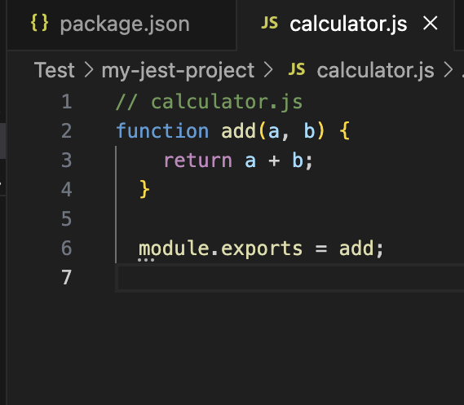

Create a test.js file for sample code validation.

In the package.json file please change the script of test to method Jest

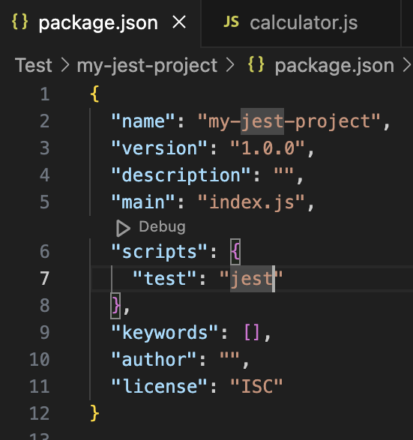

Now run the command using “npm test” in the Terminal at the folder created for json.

Jest will automatically discover your test files and run them.

The output seems like below:

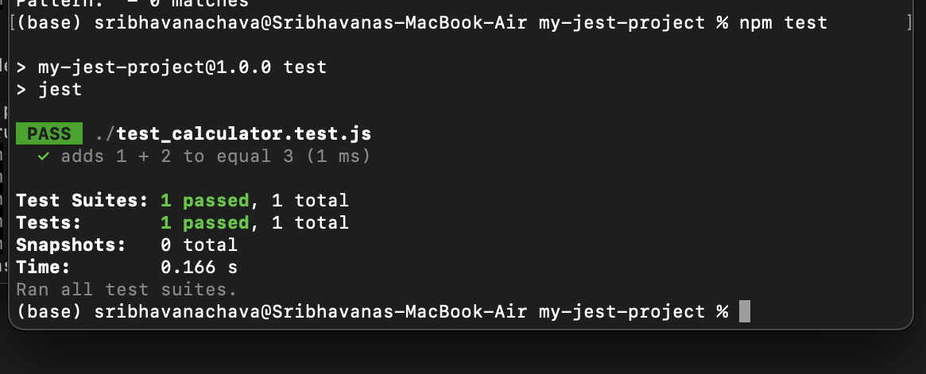

After carefully analysing every framework and considering the requirements of "Project Echo," I am sure that these suggestions will offer the most efficient and expandable ways to test in both Python and Node.js environments.

Documented by,

Sri Bhavana Chava (S224041382)